Cultural and Ethical issues about Exercise in Muslim World
Institutional Affiliation
Name
Course

Talk about how Muslims do not exercise due to their culture. About economics behind how expensive gyms are. Ethical things women and their troubles in feeling like outsiders in gyms.
Introduction
Lack of adequate activity or exercise among Muslim adults threatens worldwide public health since it is a prime behavioral risk factor which is linked to some of the chief non-communicable diseases such as colon and breast cancer, type 2 diabetes, and coronary heart diseases. These diseases that have been partly contributed by lack of exercises have long-term effects that have progressively continued to burden national economies. It is important to reduce its pervasiveness so that it can decrease premature mortality and lead to having a healthier population (Gholizadeh & Davidson, 2011). The World Health Organization (2013) came up with a campaign that it had geared towards prevention of the non-communicable diseases. It set voluntary global targets that were also geared towards declining physical inactivity by 10 % (Kahan, 2015). This paper strives to answer the following questions: why Muslims women do not exercise? How does economics affect the issue concerning exercises and what ethical things affect women concerning exercises? Also, why do women feel like outsiders in the gyms? The Muslim women are not restricted from having physical activities, but the need to maintain modesty does obstruct them from taking part in co-ed gyms or studios.
Abstract
Muslim women have been limited in terms of having exercises. They are not allowed to mix with the public in the public gyms. Thus, it can be asserted that they have been left behind in terms of having exercises. Due to the lack of adequate activity among the Muslim women, the public health has been threatened, and this has been asserted to be the main risk factor that is linked with some of the major non-communicable diseases such as colon and breast cancer, type 2 diabetes, and coronary heart diseases. The World Health Organization conducted research concerning inactivity that was prevalence. It considered a nation to be Muslim its Muslim population consisted equal or more than half of its total 2010 population. In August 2014, the WHO organization had data that indicated the prevalence of inactivity that came from nations such as Yemen, Turkmenistan, Tajikistan, Somalia, Kyrgyzstan, Kosovo, Djibouti, Brunei, and Azerbaijan.
How Muslim Women do not Exercise due to their Culture
Muslim women are not restricted to doing exercises. Muslim women are encouraged to take part in exercise so that they can keep fit. However, Muslim women are restricted due to the requirements that they are supposed to adhere to take part in exercises. It is hard for Muslim women to stay fit while adhering to their religious principles concerning modesty (Alvi, 2008). Islam does not restrict any Muslim from doing exercises- in fact, all Muslims are encouraged to get involved in exercises so that they can stay fit and also are encouraged to have healthy meals. However, Muslim women come across a special set of challenges in a culture of co-ed gyms and skimpy workout wear (Kahan, 2015).
Muslim women in the United States wear hijab in public, loose garments covering their body and hair. Such garments can be said to hinder movement and can also add discomfort in times of exercises. However, women can show legs up to the knees and their hair in front of other women. Also, Muslim women are often limited in their choice regarding activities, as well (Hamzeh & Oliver, 2010). There is a section of Muslims who believe certain yoga chants are forbidden, as well as certain poses such as sun salutations. Sun salutations are supposed to be exercised when worshipping Allah.
Muslim women are forbidden to exercise workouts around men, for the sake of modesty. Thus, this kind of modesty can be claimed to be of benefit and at the same time to be a liability. However, Muslim women are spared some of the body-image issues that other women in the other religions face, but, this is on the other detrimental to their physical well-being (Hamzeh et al., 2010). Muslim women are not supposed to mix with men in the public gyms or studios. Thus, the issue of there being a culture that does not allow women to mix with men is also leading to women failing to have physical activities.
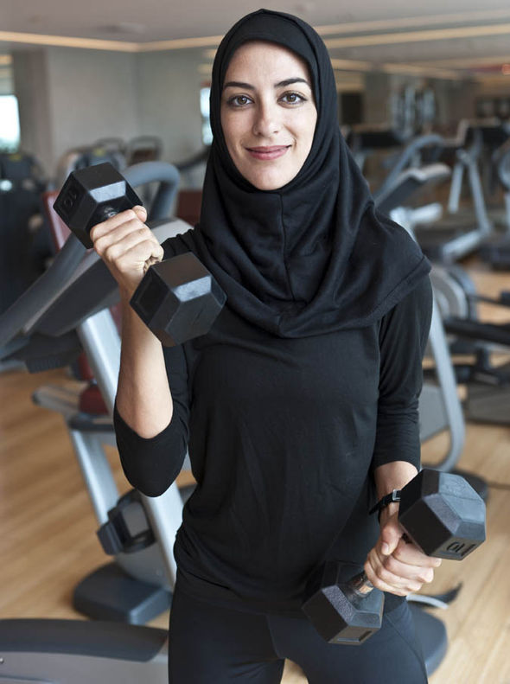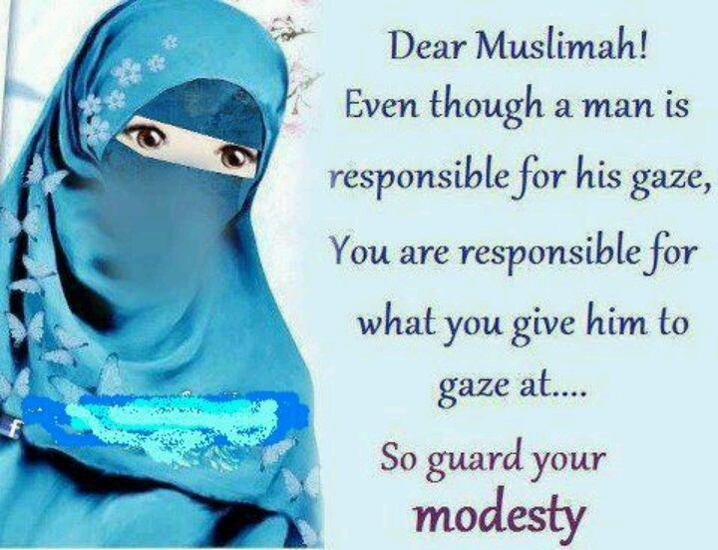
The Cost of Gym
Fitness might be the passion of all Muslim. However, there are some factors that might hinder one from doing exercises. Some of these factors might be culturally-related, as well as financial ones. Due to the related cultural issues, some Muslims, specifically the Muslim women, might be necessitated to set up their gyms at home. But, there are also other factors that they are supposed to consider before coming up with the decision to set up a gym at their home such as the cost that is needed to set up a gym (Gholizadeh et al., 2011). Thus, the biggest question is: "how much is required to set up a gym at home?" before setting up a gym that is more expensive at home, a person should start with a simple set up to see if he or she will be using it as required. Some people might fail to utilize the gym equipment as required.
In addition to testing the level of commitment, kicking-off with a single piece of multi-use equipment is a great way to build a great gym on a budget. People should avoid going into debt to have a gym at their home. For instance, a person can start with a pair of rings or a used kettlebell, which might both cost $50. Both of these items might provide one with lifetime training. It will be better if a person keeps his or her end goal in mind. By keeping the end goal in his or her mind, he or she will be in a position to eliminate the items that might not be necessary to buy. And by this, the person will be able to cut-off some of the unnecessary costs.
Why Women feel like Outsiders in Gyms?
The Muslim women find it not easy to do exercises in co-ed gyms or studios. According to the Muslim culture, women are not supposed to show their body parts and hair to men other than their husbands. During exercise, the Muslim women might find it hard since they are required to adhere to modesty. Through modesty, Muslim women are supposed to adhere to Islamic rules. The women are not supposed to show bare body parts to men. Due to this, Muslim women might find it hard to do exercises due to the rules that are governing the way they are supposed to get into the exercises. Thus, they are required not to go against what is required of them by the Islamic rules as far as modesty is concerned. But working out in a place where there are no men can make it easier to balance the two; modesty and the adhering to the Islamic rules.
Thus, Muslim women have to struggle so much with efforts to maintain their dignity. They do so by having their body covered with clothes and their hair covered by the hijab or scarfs. They are required not to show their body parts, but this should not stop Muslim women from having physical activities. It is not easy for the women to perform physical activities while in such heavy clothing or even having covered their body just like the way they normally do. During exercise heat usually build up, and if the Muslim women are in a co-ed gym or studio, they will be uncomfortable due to the excess heat that is being generated from the physical activities that they do.
In conclusion, absence of adequate exercise among Muslim grown-ups undermines overall general wellbeing since it is a prime conduct hazard factor which is connected to a portion of the major non-transferable maladies, for example, colon and bosom malignancy, type 2 diabetes, and coronary heart sicknesses. These maladies that have been mostly contributed by the absence of activities have long haul impacts that have continuously kept burdening national economies. It is critical to lessen its inescapability with the goal that it can diminish untimely mortality and lead to having a healthier populace. Muslim women are restricted by their culture from taking part in co-ed gyms. Islamic laws require women to give respect to modesty (Kahan, 2015). As indicated by the Muslim culture, ladies shouldn't show their body parts and hair to men other than their spouses. During the activity, the Muslim ladies may think that it is hard since they are required to hold fast to humility. Through humility, the Muslim ladies should hold fast to Islamic standards. The ladies shouldn't show exposed body parts to men. Because of this, the Muslim ladies may think that it is difficult to do practices because of the principles that are overseeing the manner in which they should get into the activities (Cohen & Peachey, 2014). In this manner, they are required not to conflict with what is expected of them by the Islamic principles as far as modesty is concerned.
References
Alvi, S. (2008). An analysis of how hijabi youth experience social activities in Ottawa secondary schools (Doctoral dissertation, University of Ottawa (Canada)).
Cohen, A., Melton, E. N., & Peachey, J. W. (2014). Investigating a coed sport’s ability to encourage inclusion and equality. Journal of Sport Management, 28(2), 220-235.
Gholizadeh, L., DiGiacomo, M., Salamonson, Y., & Davidson, P. M. (2011). Stressors influencing Middle Eastern women's perceptions of the risk of cardiovascular disease: A focus group study. Health care for women international, 32(8), 723-745.
Hamzeh, M. Z., & Oliver, K. (2010). Gaining research access into the lives of Muslim girls: Researchers negotiating muslimness, modesty, inshallah, and haram. International journal of qualitative studies in education, 23(2), 165-180.
Kahan D. (2015). Adult physical inactivity prevalence in the Muslim world: Analysis of 38 countries. Preventive medicine reports, 2, 71–75. doi:10.1016/j.pmedr.2014.12.007

